**Essential Logistics KPIs and Metrics Part 1**

These 18 logistics metrics can help your business manage costs and improve customer satisfaction. These costs relate to shipping, distribution, transportation, warehousing and logistics performance. Use these KPIs to identify problems and optimize your processes.

**Formulas for Transportation KPIs**

* **Average Cost per Order:** The average cost per skid or order is a combination of all the hidden and more obvious costs. The metric compares the number of skids or orders to the total cost of the shipment or effort. This measurement can help to identify skids or orders whose costs are unusually high.

|  |  |
| --- | --- |
| **AVERAGE COST PER ORDER EXAMPLE**  **St. Peter Hardware** | |
| **Marketing campaign** | **P 500** |
| **COGS** | **1,200** |
| **Packaging** | **50** |
| **Shipping costs** | **200** |
| **Storage costs** | **100** |
| **Number of orders** | **300** |

**Use Excel in Solving:**

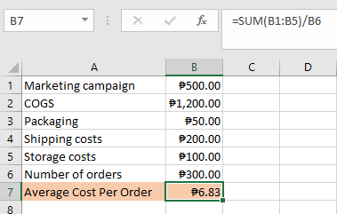

In St. Peter Hardware scenario, the average cost per order is P6.83.

* **Average Transportation Cost:** The average transportation cost is the average cost of transportation expenses compared to gross monthly income. This measures the distribution of the expenses from order placement to delivery. This includes actual transit costs and those for order processing, which is a small percentage of administration, inventory carrying and warehousing.

**Average Transport Cost Example:** A company has an P800 average monthly transportation cost and P10,000 monthly gross income

**Use Excel in Solving:**

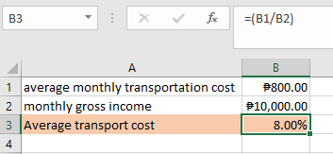

This company spends about 8% of its monthly income on transportation.

* **Freight Cost per Unit Shipped:** Freight cost per unit shipped is the total freight costs divided by the number of units shipped in the period. The measurement considers things like cargo mix and making sure the container is not underloaded. Companies want full container loads.

**Freight Cost per Unit Shipped Example:** P4,200 for 6,000 units

**Use Excel in Solving:**

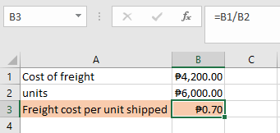

In this example, the freight was P.70 per unit in shipping.

**Formulas for Supply KPIs**

* **Transit Time to Distance:** The transit time to distance compares the distance a shipment travels to the time it takes it to go from pickup to destination.

Transit Time to Distance Example: 5 days, 2,000 miles

**Use Excel in Solving:**

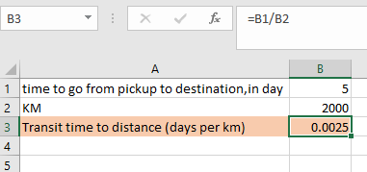

In this example, the travel time to distance is 0.0025 days per km.

* **Stock Rotation:** Stock rotation, also known as inventory turnover, is the number of times a company sells its inventory in a period. This metric helps companies monitor aging stock.

**Stock Rotation Example:** St, Peter Hardware has P10,000 in sales and P5,000 in average inventory.

**Use Excel in Solving:**

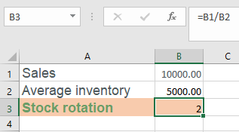

In this scenario, St, Peter Hardware sells through its stock 2 times in this period.

* **Out-of-Network Shipment:** Out-of-network shipments are the unusual shipments ordered due to stock depletion. These shipments can be expensive. The ratio of out-of-network shipments compares them to total shipments.

**Out of Network Shipment Example:** There are 20 out-of-network shipments out of the 5,450 shipments in this period.

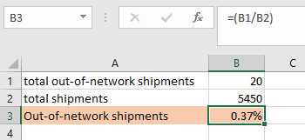

In this situation, 0.37% of shipments in this period were out-of-network.

**Examples of Distribution KPIs**

* **On-Time Final Delivery:** On-time final delivery, also known as on-time delivery (OTD), is the ratio of products delivered on-time to customers compared to the total number of shipped products. The KPI measures supply chain efficiency and performance in delivery operations. The units shipped on-time is for the whole order, not broken down by piece.

**On-Time Final Delivery Example:** Of the 18 orders delivered this week, 15 were delivered in full, two partial deliveries and one order pending.

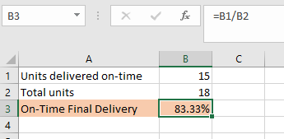

In this scenario, the company delivered 83% of products on-time. The goal of OTD is always 100%.

* **On-Time Pickup:** On-time pickup is the number of pickups the freight carrier made on-time compared to the period's total shipments. This metric shows carrier performance, which boosts customer satisfaction and shipping efficiency. Experts recommend relying on documentation transit time, not on the carrier's data.

**On-Time Pickup Example:** This month, St. Peter Hardware picked up 43 shipments on time out of a total of 46 shipments.

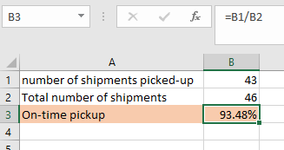

In this example, the on-time pickup performance was 93.5%. Experts consider anything above 90% acceptable.

* **On-Time Shipping:** On-time shipping is how close the carrier came to shipping out the order when promised. Measure the number of units shipped out on time compared to the number of units shipped during that period. Orders must be in-full to count toward this metric.

**On-Time Shipping Example:** Of the 23 orders shipped out on-time, 18 were in-full and on-time, three were partial orders shipped on-time and two were behind what the company promised.

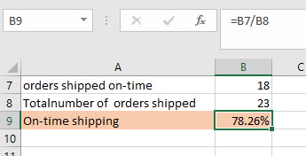

Using these numbers, the company shipped 78.3% of orders out on-time. The goal is always 100%.